# SAD Document - Process View

**Figure 1 - Creating a Reservation**

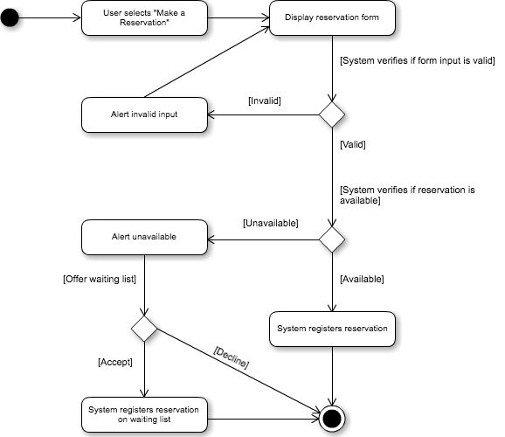

**Figure 2 - Cancel Reservation**

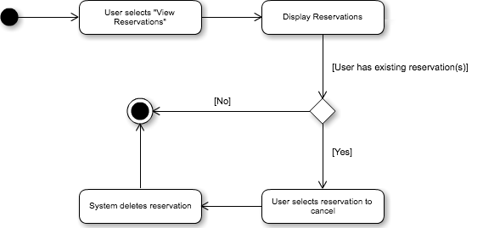

**Figure 3 - Modify Reservation**

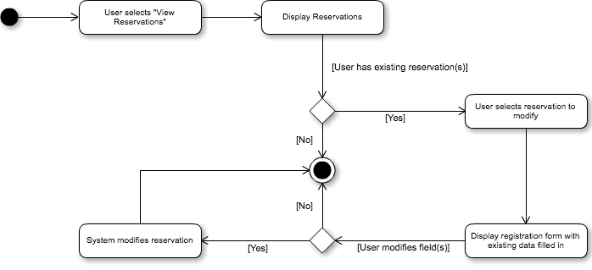

**Figure 4 - Authentication**

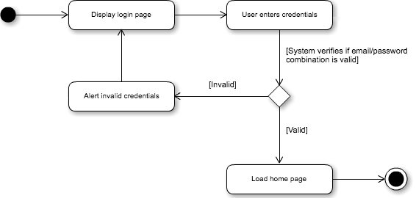

**Figure 5 - Change Profile Details**

